**CAR RENTAL MANAGEMENT SYSTEM**

**TEAM MEMBERS:**

**1.NIHARIKA D**

**2.YOSHITHA R**

**3.HARSHITHA R**

**SWAGGER UI OUTPUTS:** 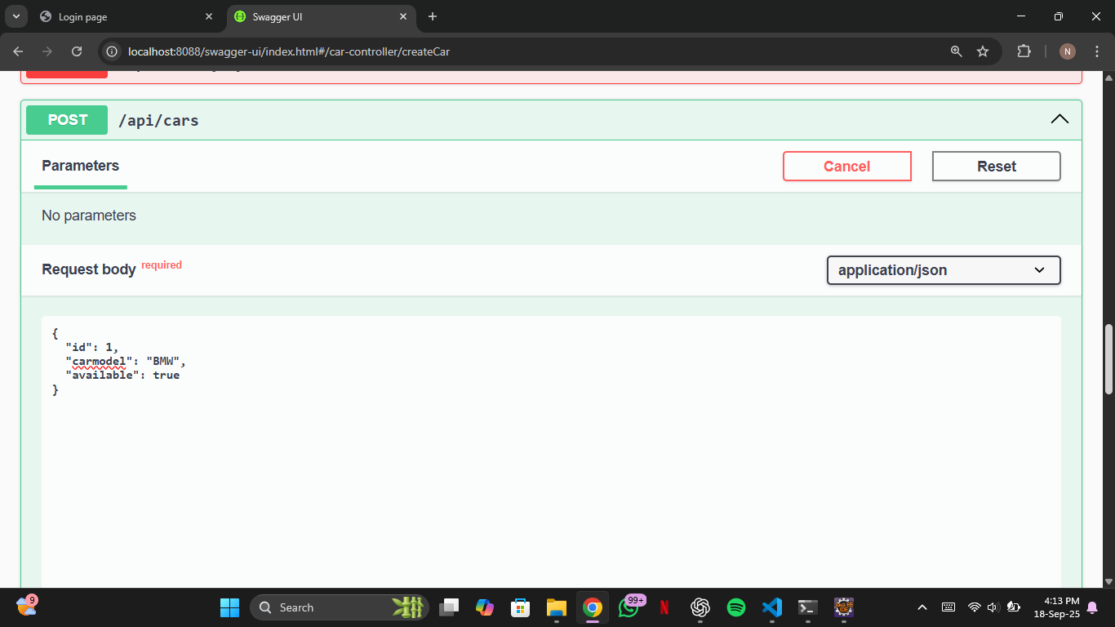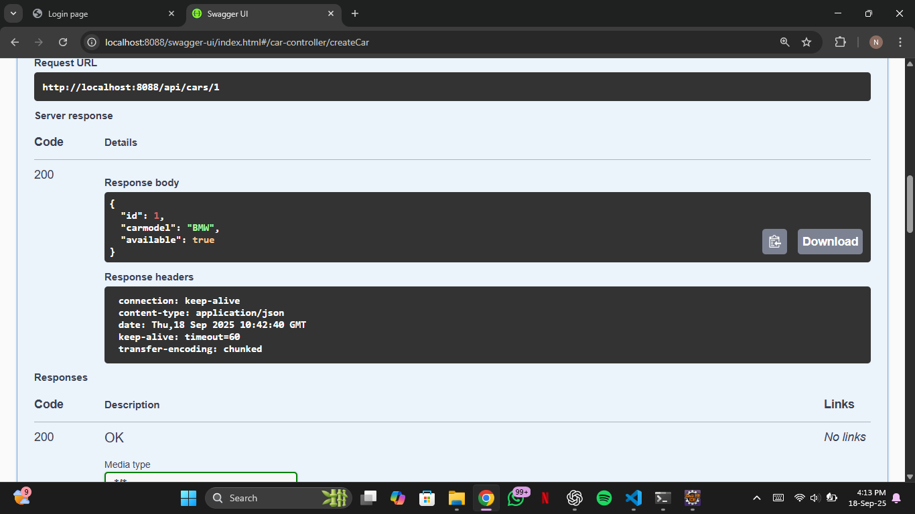

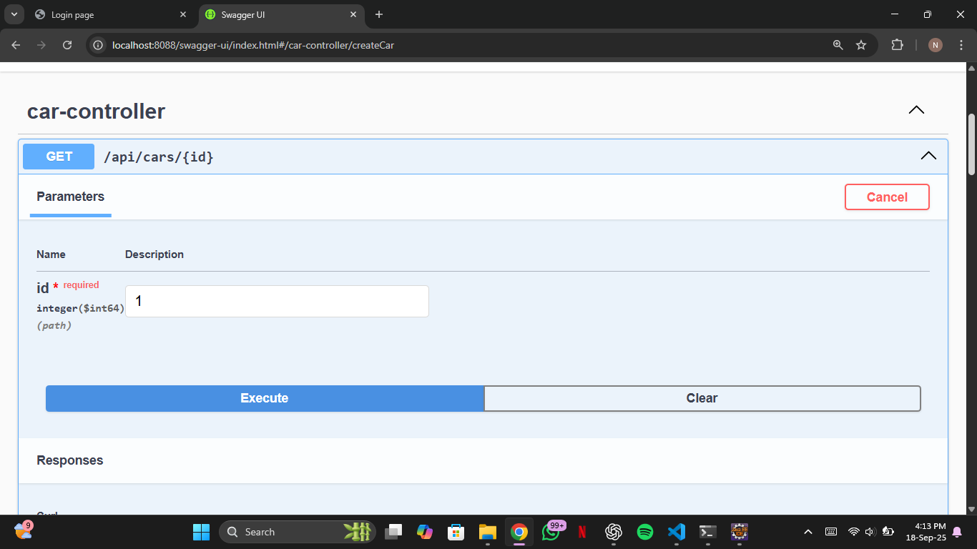

**INSERTED DATA IN MYSQL WORKBENCH:**

